# **How to Export Postman Collections?**

***Last Updated On***

[**HOME**](https://qaautomation.expert/)

In this tutorial, we will go through the steps to ***export a Collection***in Postman.

***Step 1:*** Open Postman and navigate to the collection you want to export. Click on the ellipsis (…) icon next to the collection name.

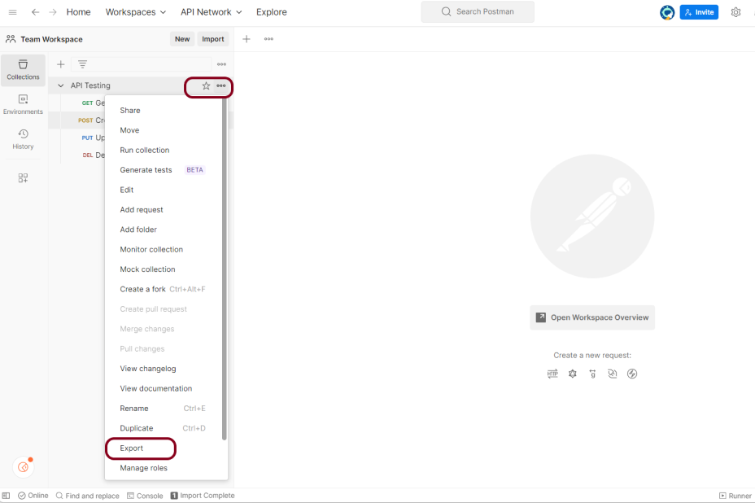

***Step 2:***Select ***“Export”*** from the drop-down menu. Choose the format in which you want to export the collection. Postman supports a variety of formats including***JSON, CSV, and YAML.***

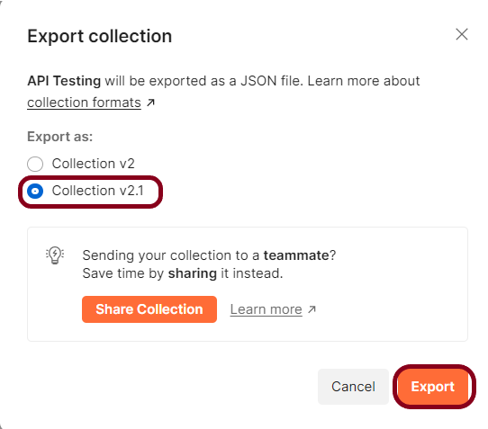

***Step 3:*** Choose the location on your computer where you want to save the exported file.

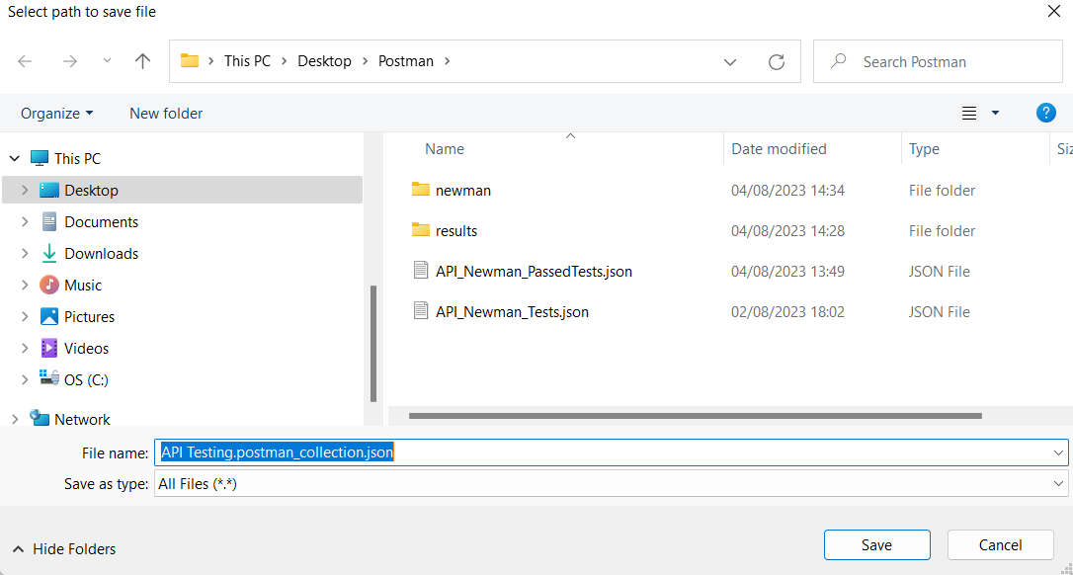

Advertisement

***Step 4:***Click ***“Save”***to export the collection.

Please keep in mind that if you wish to export a huge collection in Postman, the export procedure may take a few minutes. You may quickly share your Postman collections with others or backup your collections for future use using the exported file.

We are done! Congratulations on making it through this tutorial and hope you found it useful! Happy Learning!!